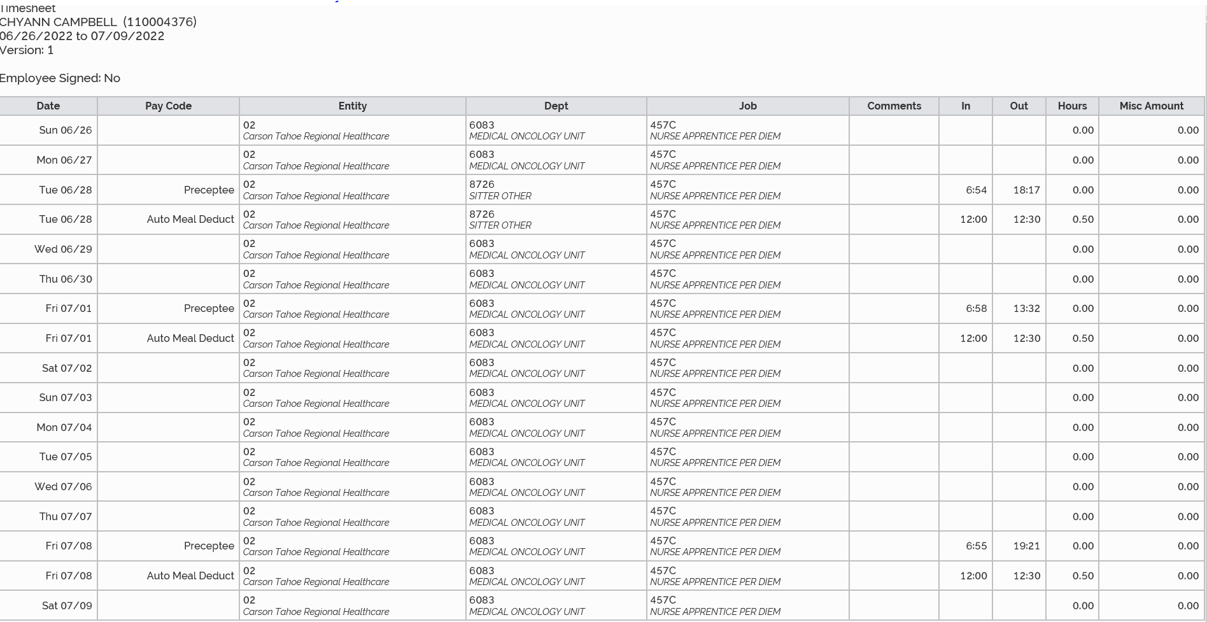
17 hours and 56 minutes
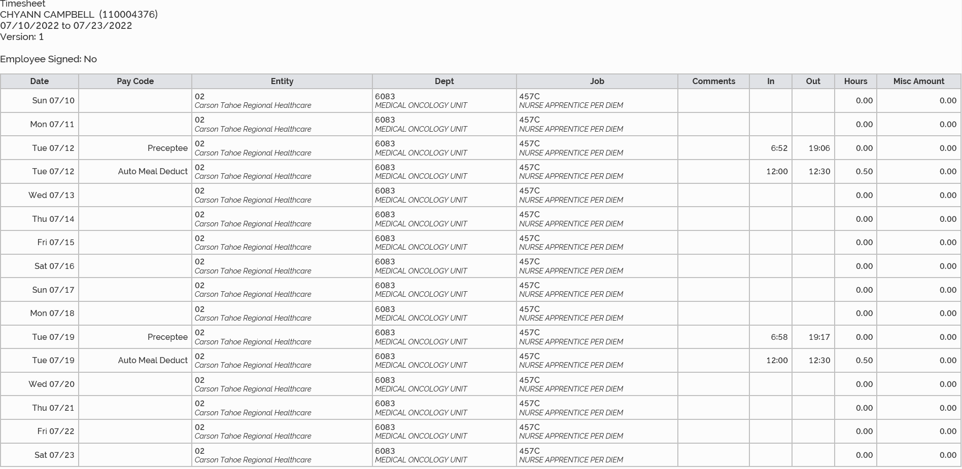
23 hours and 25 minutes
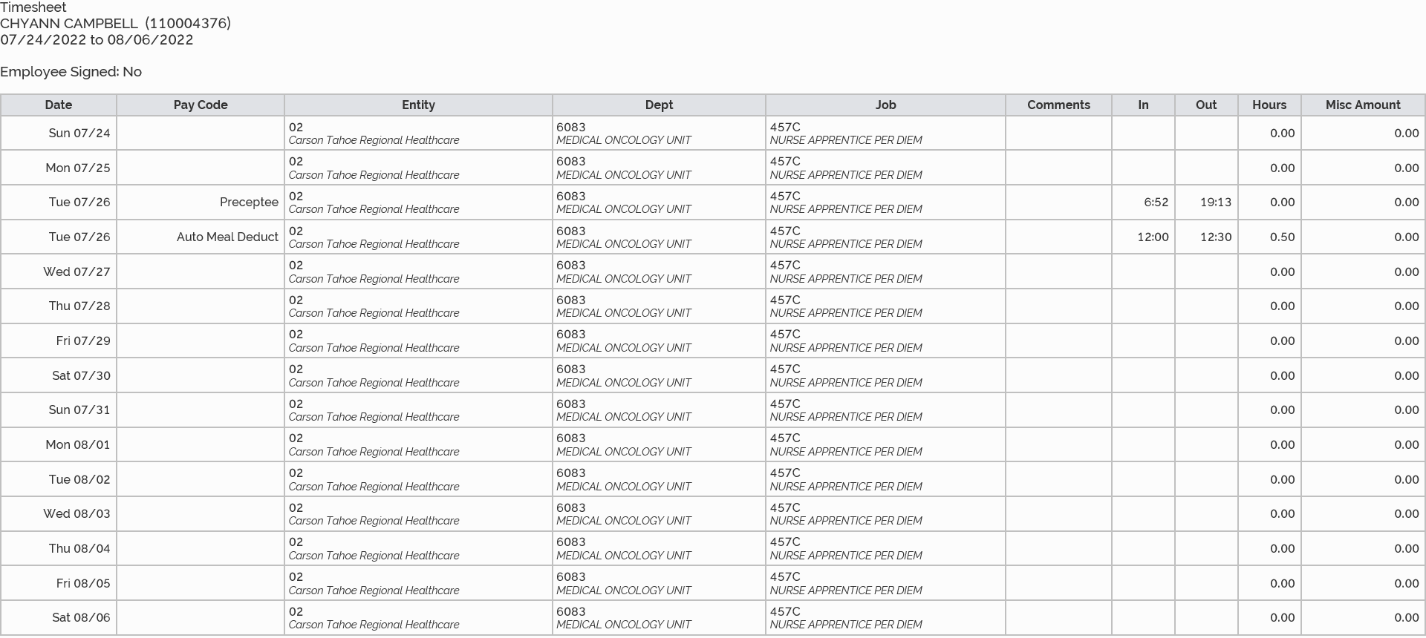
7/1/2022 6 hours
7/8/2022 11 hours and 56 minutes
7/12/2022 11 hours and 44 minutes
7/19/2022 11 hours and 41 minutes
7/26/2022 11 hours and 39 minutes
Total July Time: 53 hours

