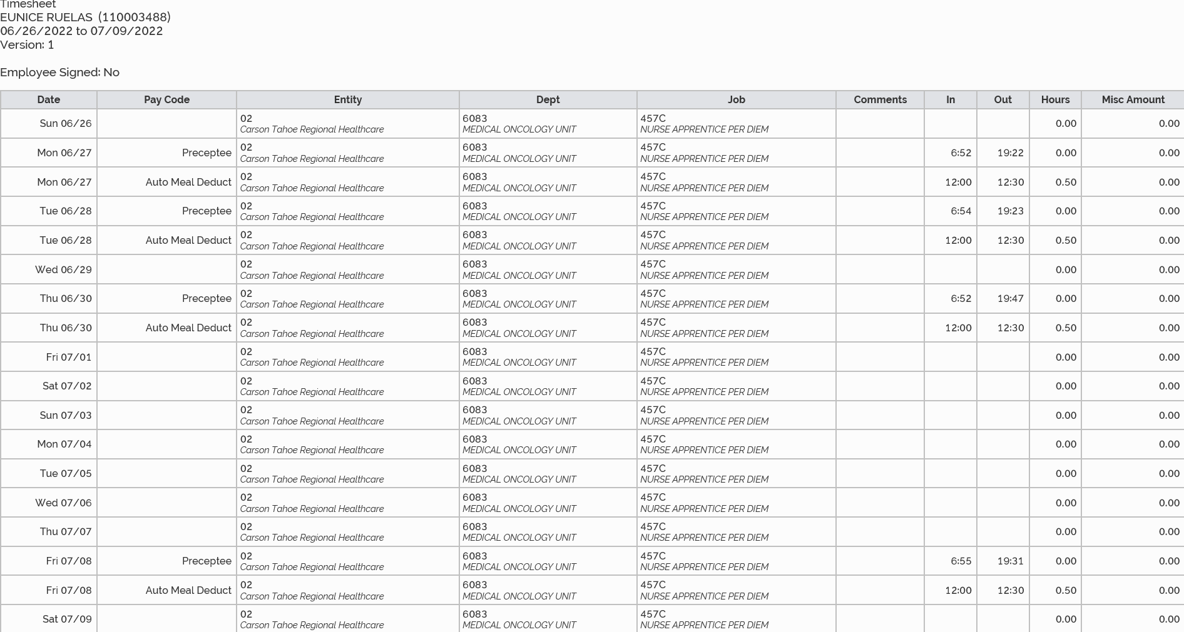
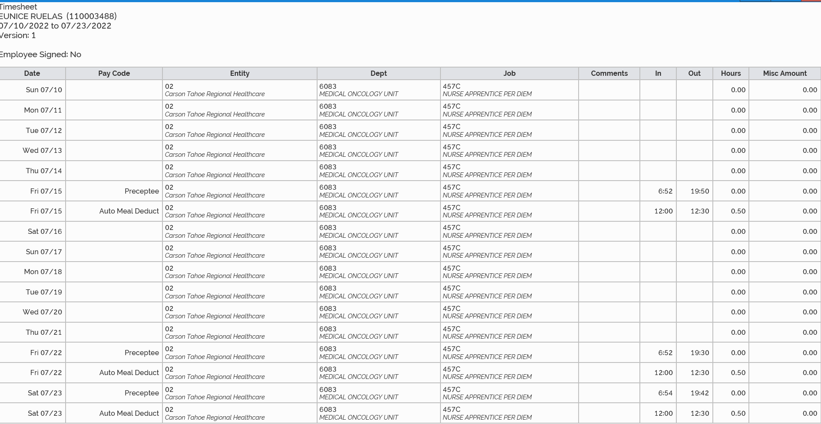
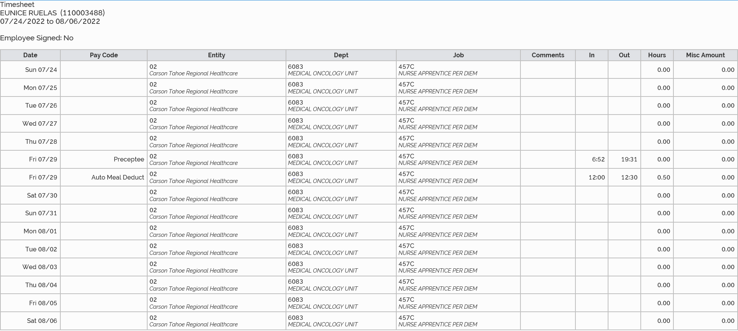
7/8/2022 12 hours and 6 minutes
7/15/2022 12 hours and 28 minutes
7/22/2022 12 hours and 8 minutes
7/23/2022 12 hours and 18 minutes
7/29/2022 12 hours and 9 minutes
Total July Time: 61 hours and 9 minutes

