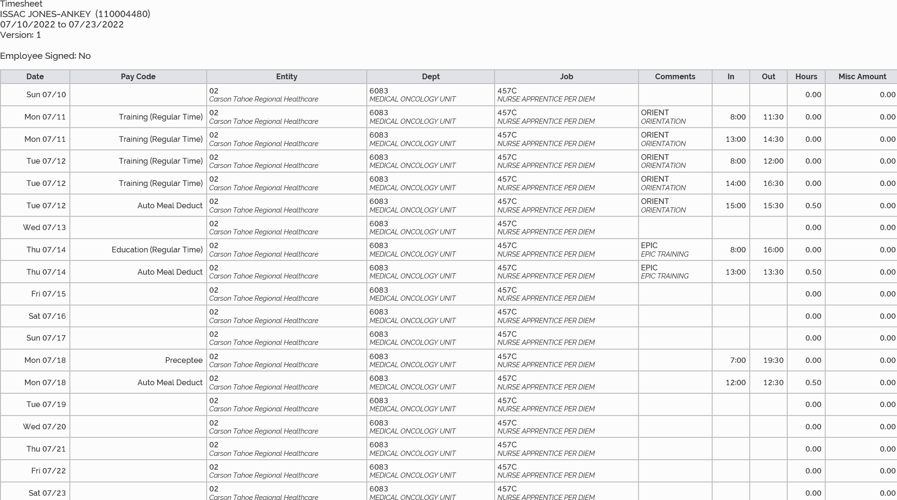
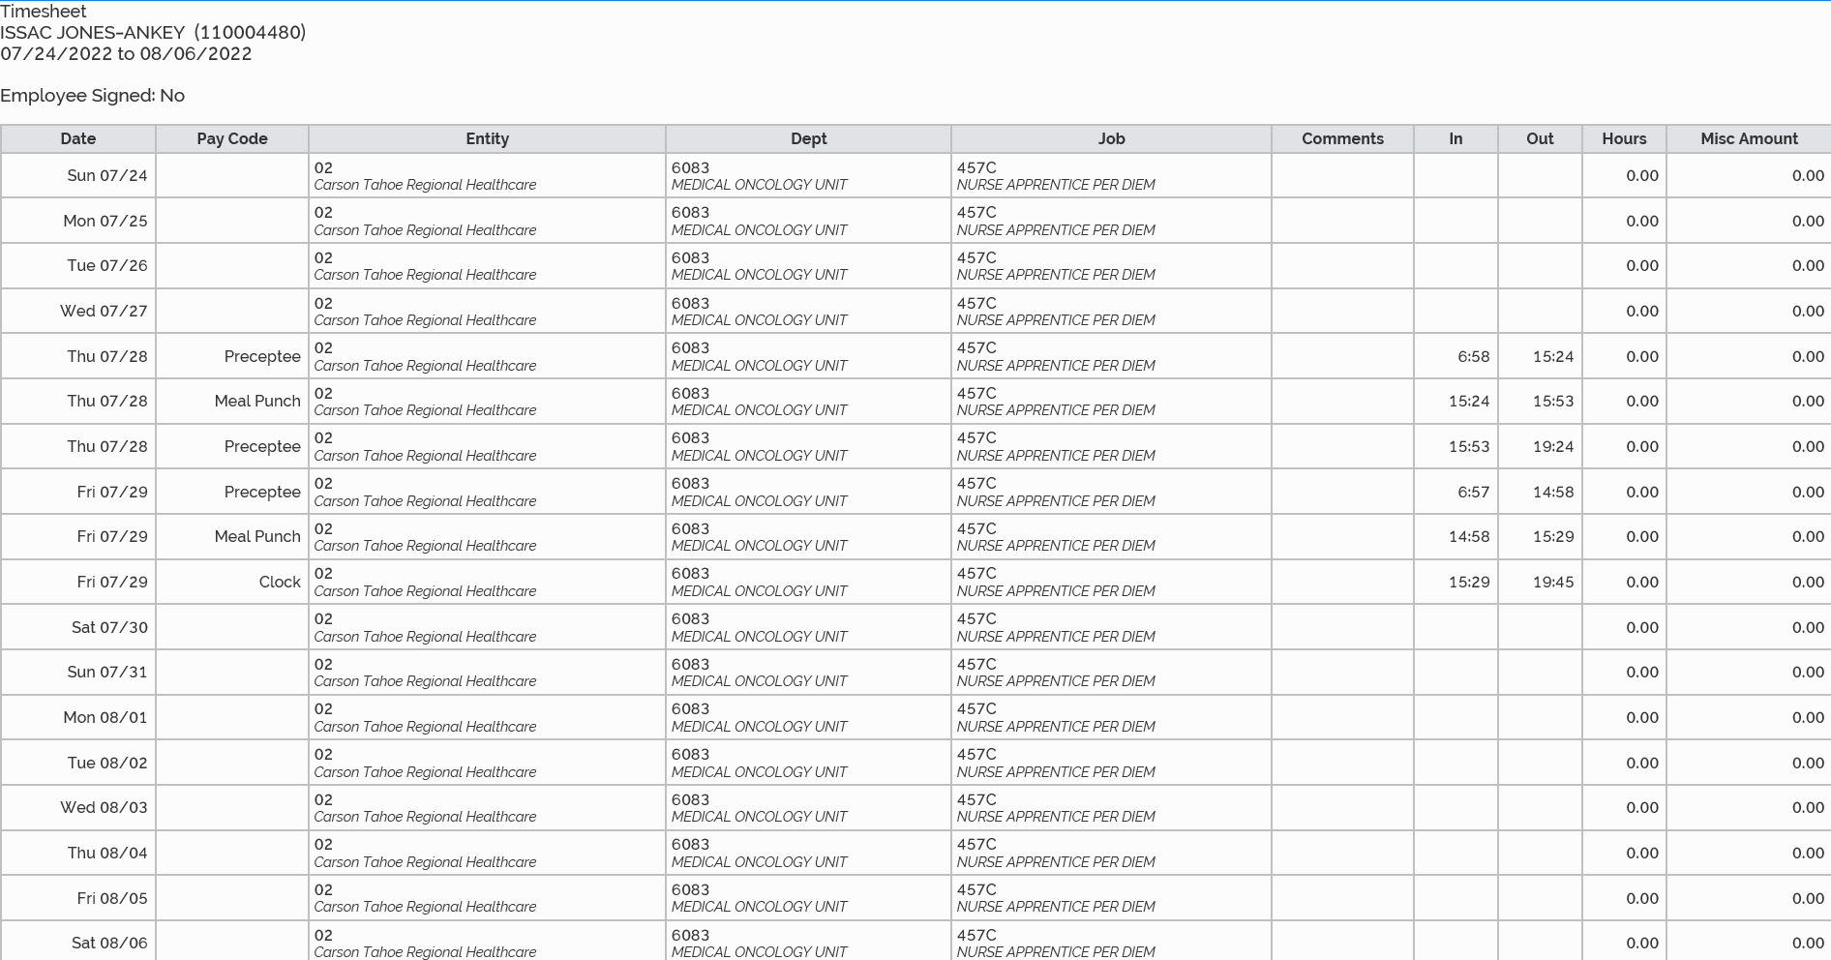
7/11/2022 5 hours
7/12/2022 6 hours
7/14/2022 7 hours and 30 minutes
7/24/2022 12 hours
7/28/2022 11 hours and 57 minutes
7/29/2022 12 hours and 17 minutes
Total July Time: 54 hours and 44 minutes

