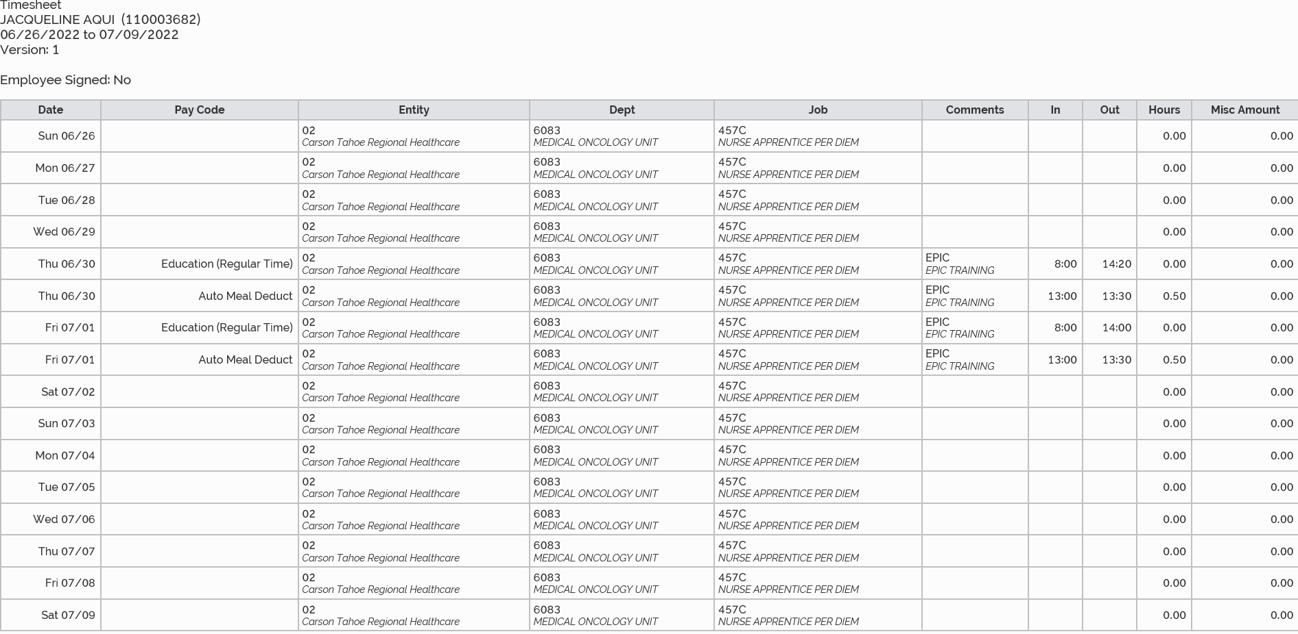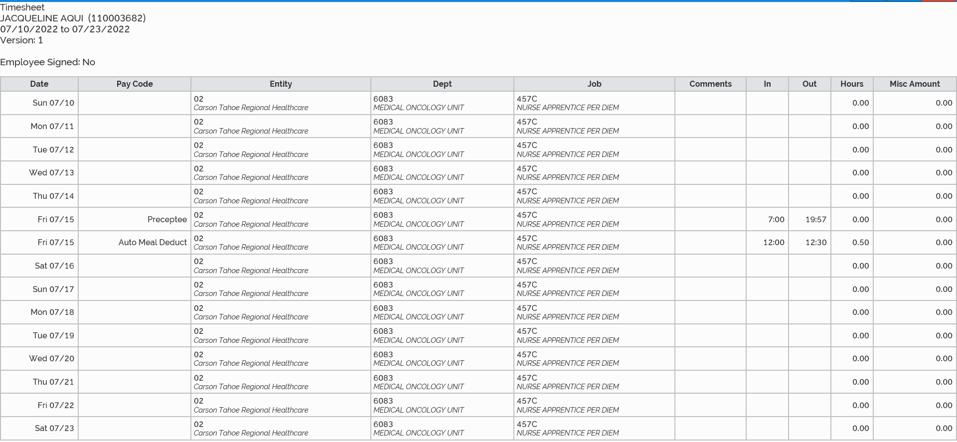
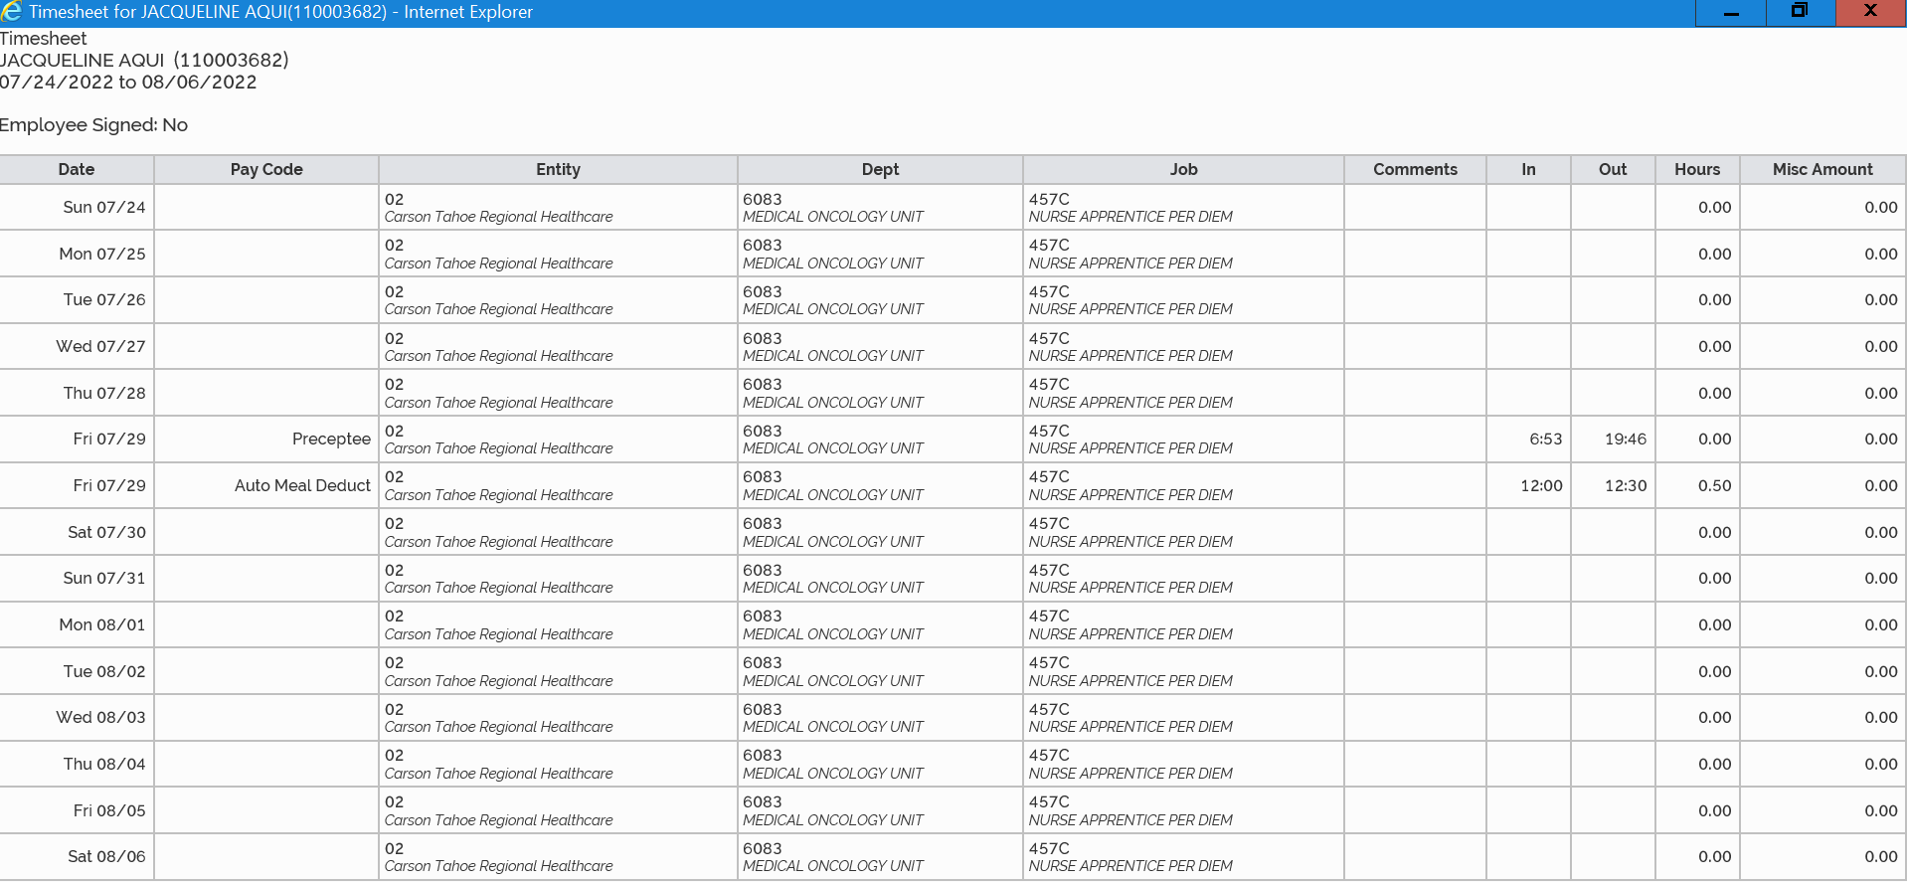
7/1 5 hours and 30 minutes
7/15 12 hours and 37 minutes
Already submitted 18 hours and 7 minutes
7/29 12 hours and 23 minutes
Apprentice picked up an additional shift expectantly

July total hours: 30 hours and 30 minutes

