Chelsi Preston NA September 2022
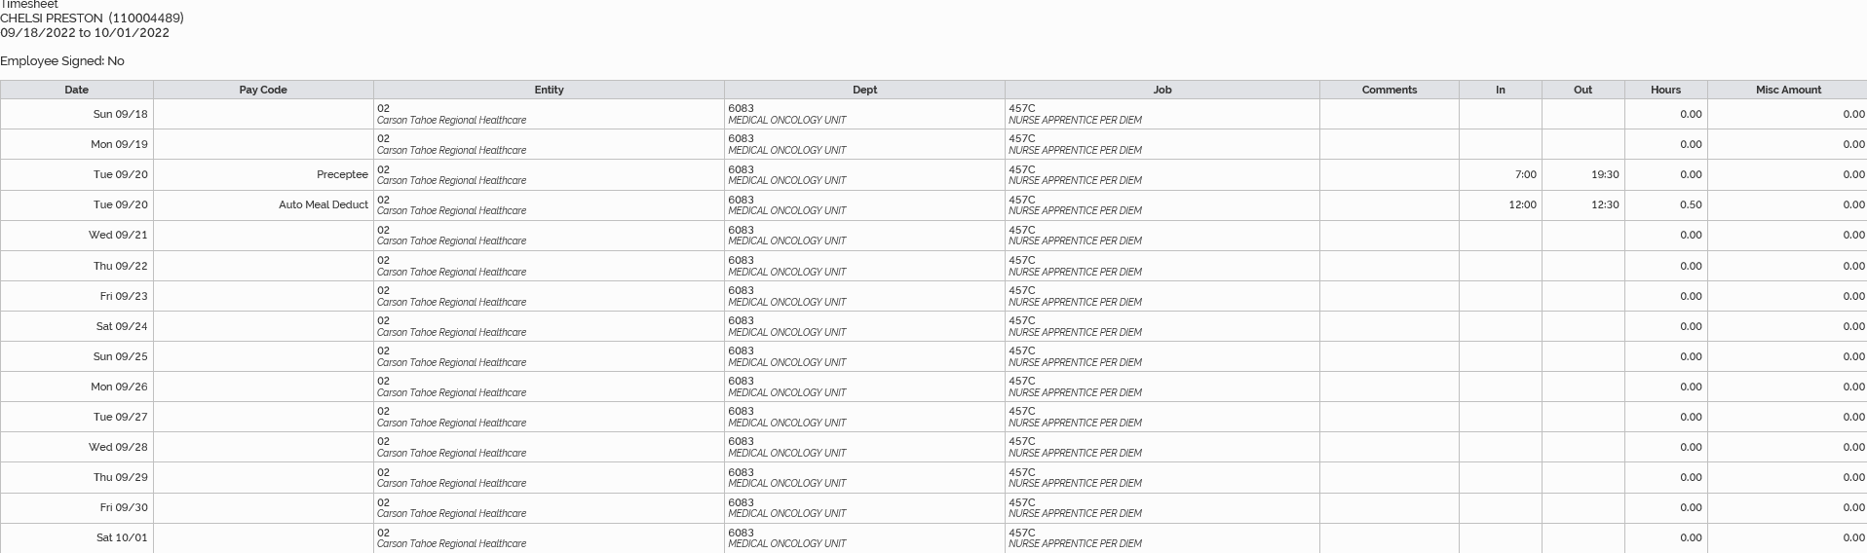

9/20/2022 12 hours
Total September hours: 12 hours

