Cherish Navarroza NA September 2022
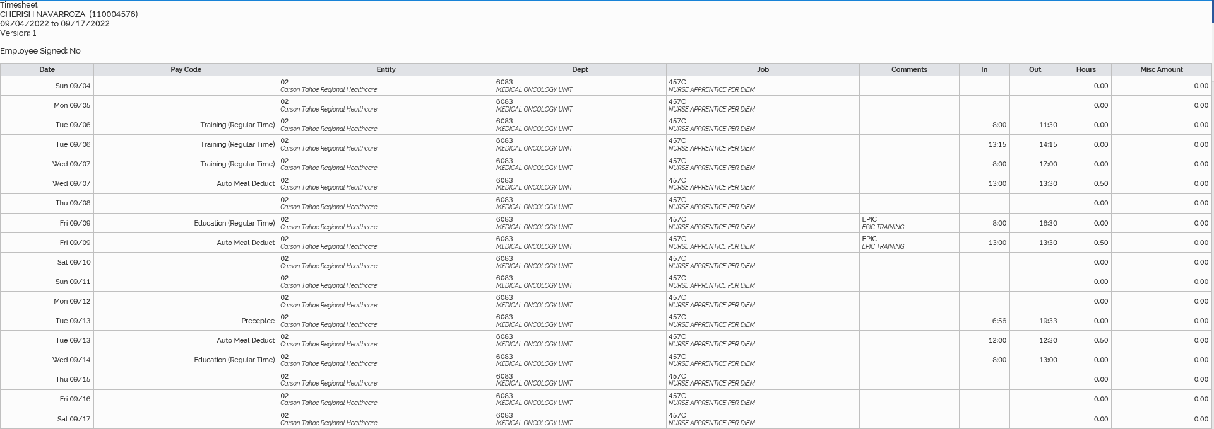
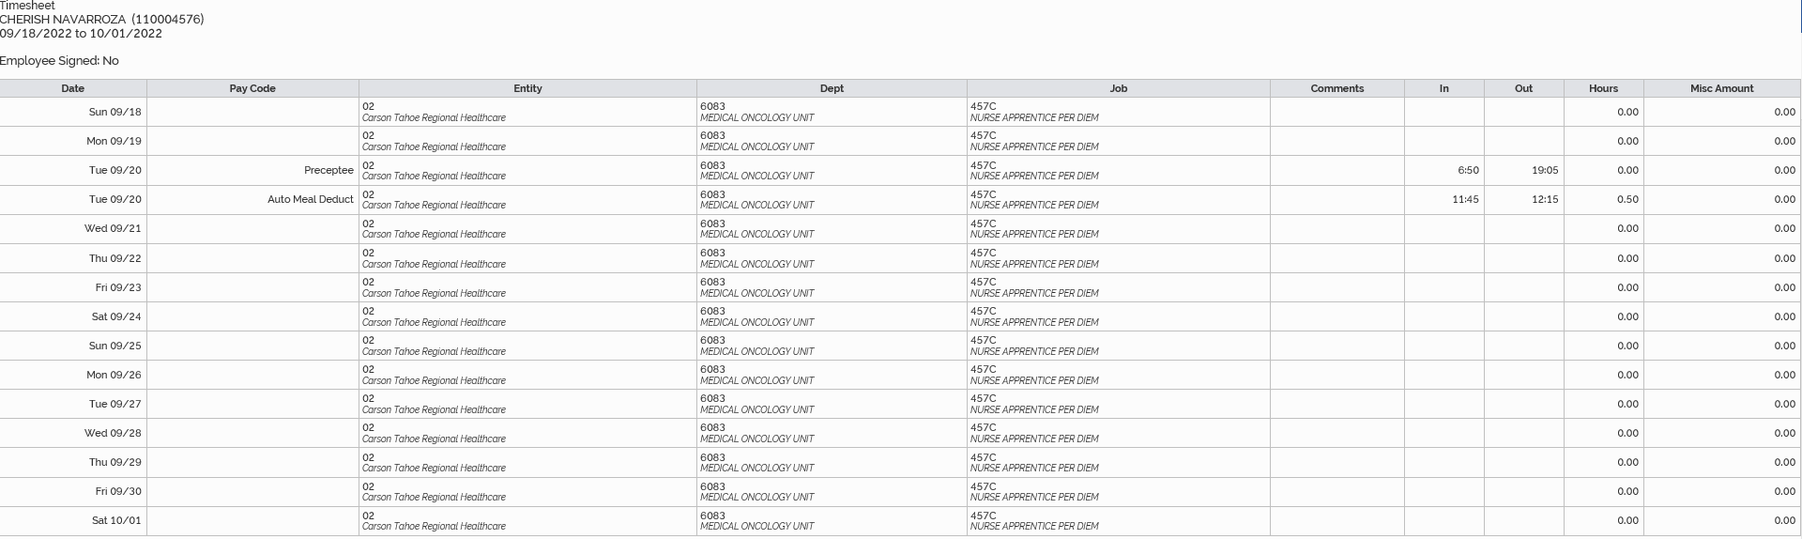
9/6/2022 4 hours and 30 minutes
9/7/2022 8 hours and 30 minutes
9/9/2022 8 hours
9/13/2022 12 hours and 7 minutes
9/14/2022 5 hours
9/20/2022 11 hours and 45 minutes
Total September hours: 49 hours and 52 minutes (49.87)

