Jacqueline Aqui NA September Hours
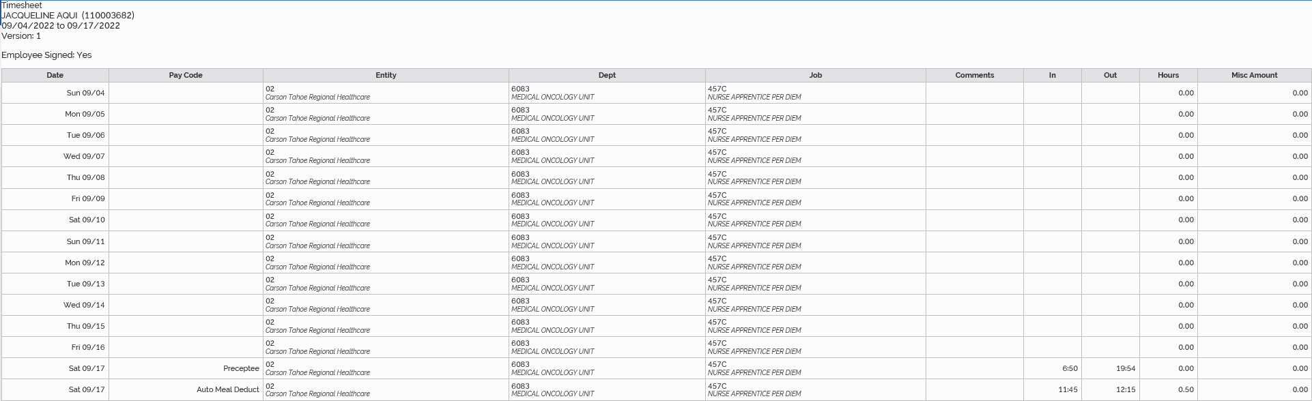
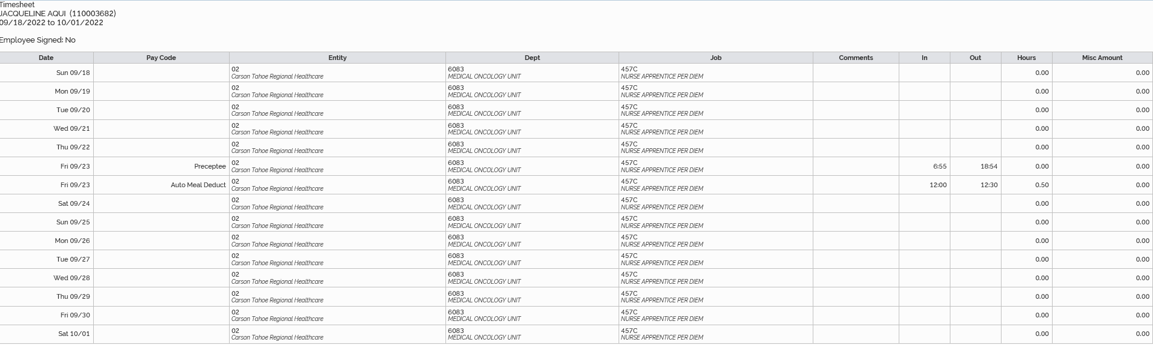
8/17/2022 12 hours and 34 minutes
9/23/2022 11 hours and 29 minutes
Total September Time: 24 hours and 3 minutes

