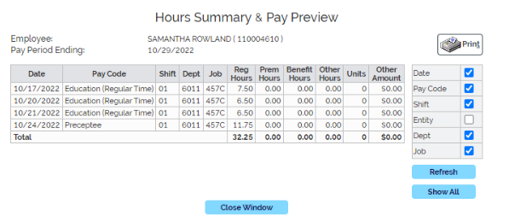

**TOTAL HOURS: 32.25**